**Department of Electronics and Communication Central University of Rajasthan, Ajmer**



Signal and System Lab

Subject ...................................................................................................

ECE 214

Subject Code ...................................................................................................

7

111

Experiment No. .......................................................................................

Date:- - -2024

Roll no:- 2022BTECE012

Name:- Ojasvee Satija

**Title: -** Write a MATLAB code to perform signal processing operations: amplitude scaling, Time shifting, Time scaling, and Time inversion.

**Apparatus required:** - Downloaded MATLAB or OCTAVE software in device.

**Introduction:**-

* **Amplitude scaling :-** Let x(t) denote a continuous-time signal. Then the signal y(t) resulting from amplitude scaling applied to x(t) is defined by

y(t) = cx(t)

where c is the scaling factor. According to Eq. (1.21), the value of y(t) is obtained by multiplying the corresponding value of x(t) by the scalar e for each instant of time t

In a similar manner for discrete-time signals, we write

y[n] = cx[n].

* **Time Scaling:-** Let x(t) denote a continuous-time signal. Then the signal y(t) obtained by scaling the independent variable, time t, by a factor a is defined by y(t) = x(at) . a > 1 the signal y(t) is a compressed version of x(t) If * 0 < a < 1 the signal y(t) is an expanded (stretched) version of x(t) . These two operations are illustrated in Fig. 1.20. In the discrete-time case, we write

y[n] = x[kn] k>0

* **Time Shifting:-** Let x(t) denote a continuous-time signal. Then the time-shifted version of x(t) is defined by

y(t) = x(t – to)

where to is the time shift. If to > 0 the waveform of y(t) is obtained by shifting x(t) toward the right, relative to the time axis. If to <0 x(t) is shifted to the left.

* **Time Inversion:-** Let x(t) denote a continuous-time signal. Then the time-inverted version of x(t) is defined by

y(t)=x(-t)

where -ve sign shifts the time axis in the -ve domain.

**Code:-**

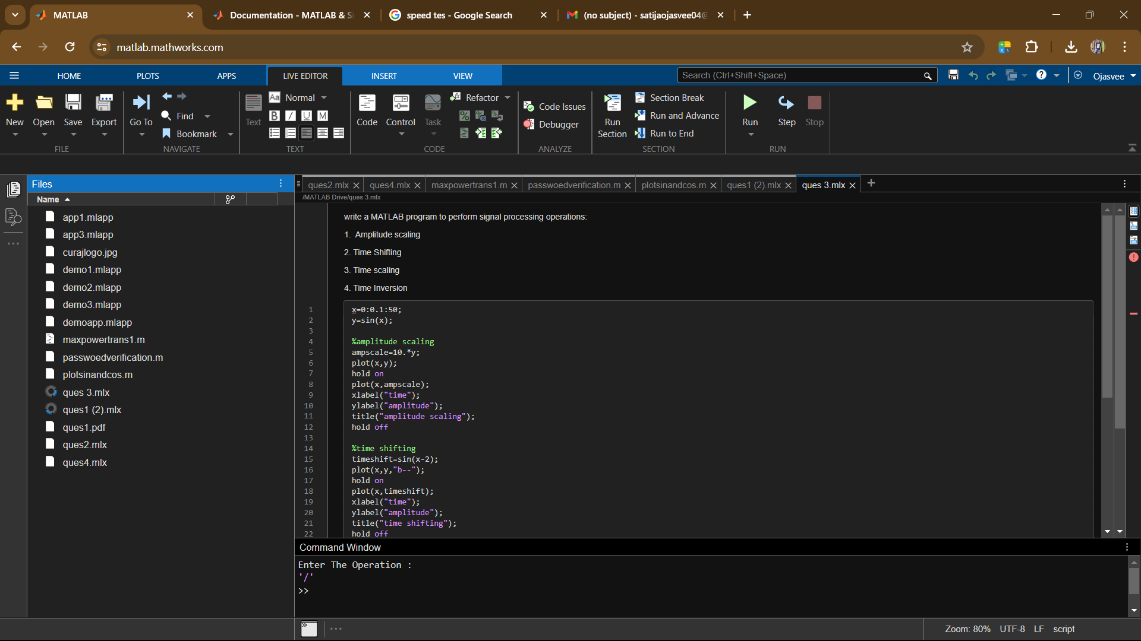

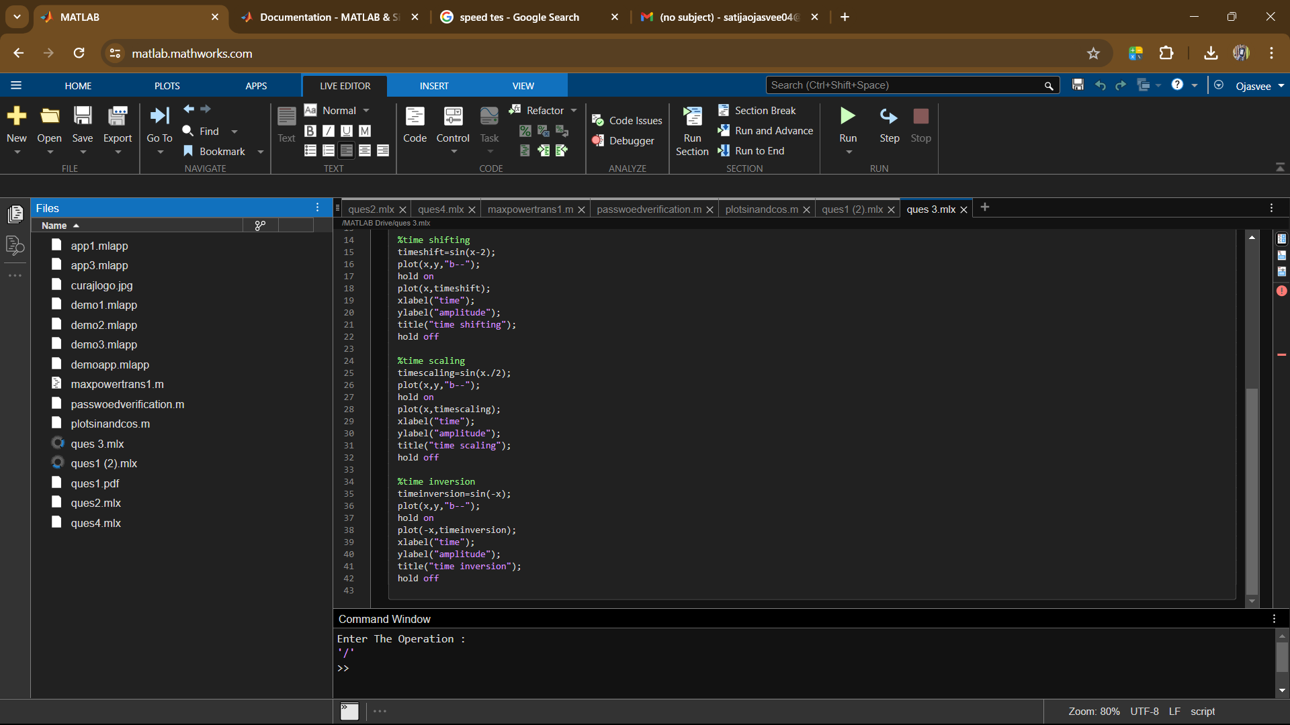

**Input and output:-**

* 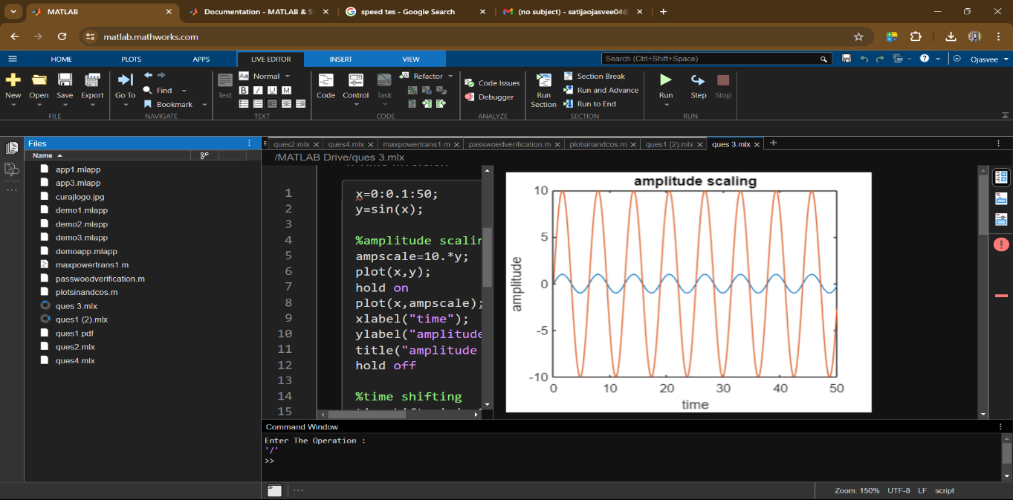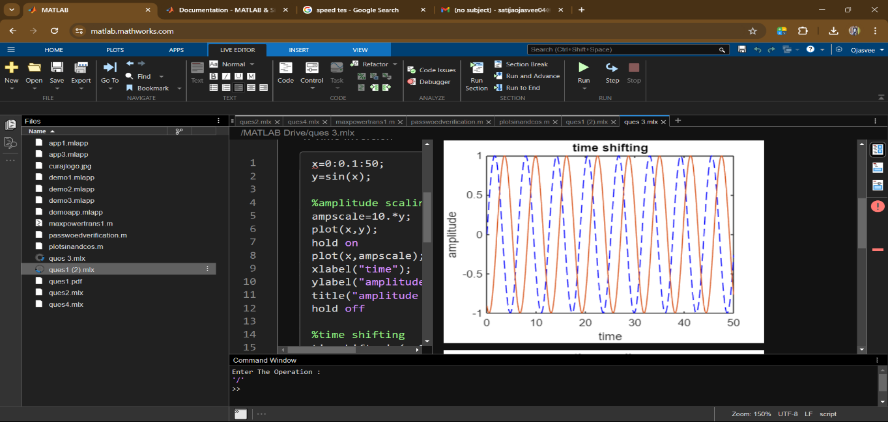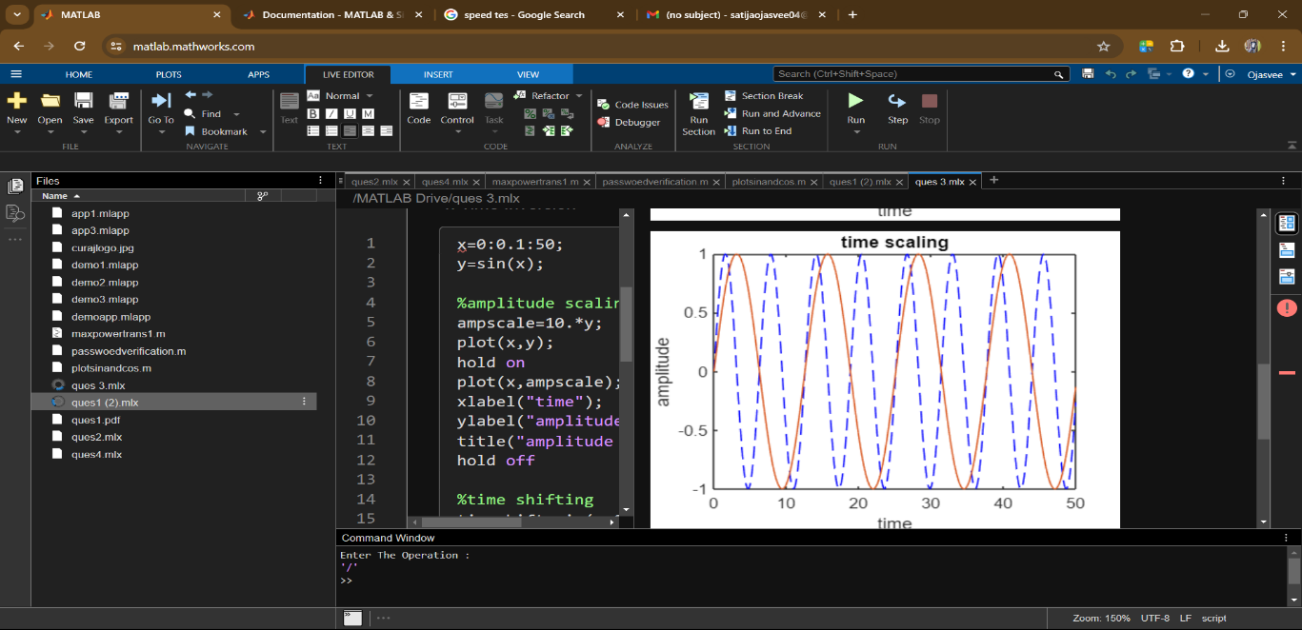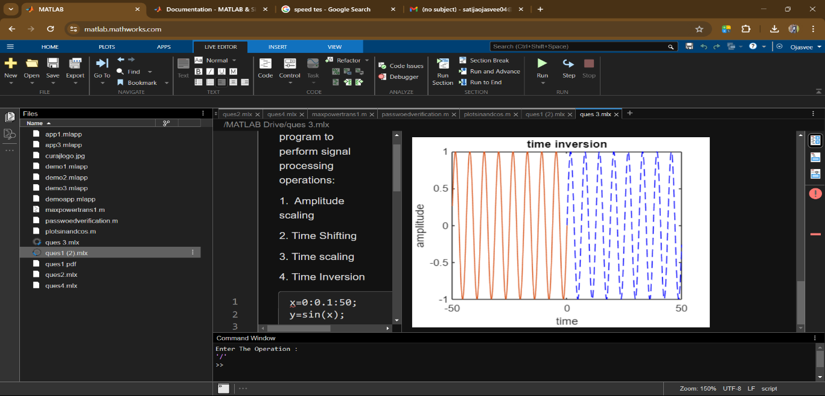

**Result:-** Performed the signal processing operations: amplitude scaling, Time shifting, Time scaling, and Time inversion operations and get the output waveforms